**POST SANCTION DOCUMENT**

This page allows users to access and search for post sanction documents through two primary methods: by date and by FI Code.

**Search by Date**

* **Date Range Selection**: Users can specify a date range by selecting a "From Date" and "To Date." After making these selections, the relevant details will be displayed in a table format.

**Search by FI Code**

* **FI Code Search**: Users can conduct searches by entering the creator and FI Code in the respective fields. Once submitted, the results will populate the table.

**Table Details**

The resulting table includes the following columns:

* **SM Code**: The unique identifier for the document.
* **Code**: Associated code for reference.
* **Creator**: The individual or entity that created the document.
* **Branch Group**: The group to which the branch belongs.
* **2nd eSign**: Status of the second electronic signature.
* **Document**: Links or references to the documents.
* **Comment**: Any relevant comments regarding the document.
* **Action**: This column indicates actions that can be taken, including the "Move to Audit" option.

**Action Status**

* If both the **SM Code** and **2nd eSign** statuses are marked as "Done," the "Move to Audit" button will appear in **green**, indicating that the document is ready for the next step.
* Conversely, if the **SM Code** is unavailable or the **2nd eSign** status is marked as "Pending," the "Move to Audit" button will display in **red**, indicating that the document cannot proceed to audit at this time.

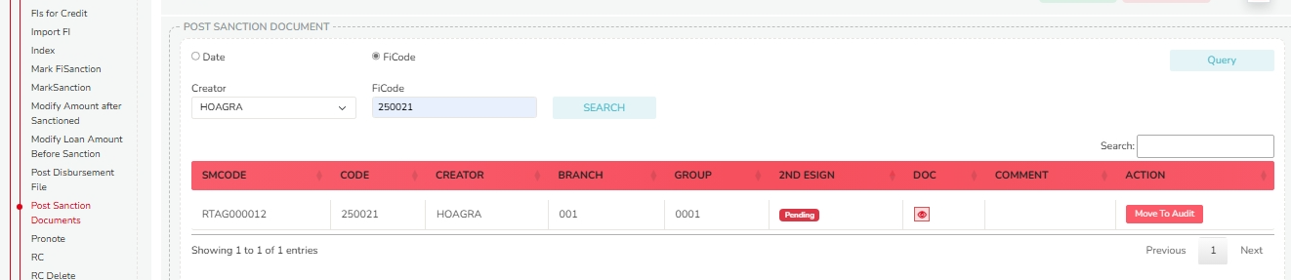

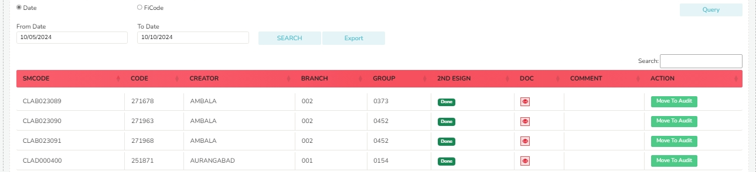

**READY FOR NEFT**

This page allows users to search NEFT details through two primary methods: by date or by creator.

**Search Functionality**

1. **Date Search**:
   * Users can select a date range by choosing a "From Date" and a "To Date."
   * After selecting the dates, users can click the "Search" button to retrieve relevant records.
2. **Creator Search**:
   * Users must first select a creator from the dropdown menu.
   * After selecting the creator, users should fill in additional fields, including Branch, Group Code, and any other necessary information.
   * Once all fields are completed, users can initiate the search.

**Data Export**

* Users have the option to export the searched data for further analysis or record-keeping.

**Search Results**

After successfully performing a search, results are displayed in a table format with the following columns:

* **SMCODE**
* **CODE**
* **CREATOR**
* **BRANCH**
* **GROUP**
* **NAME**
* **SCHCODE**
* **2ND ESIGN**
* **DATE**
* **A/C VERIFY**
* **MODEL/BRAND**
* **PINFO**
* **INCOME**
* **DOC**
* **DOCUMENT** (Users can download and view the document)

**Action Options**

In the "Action" column, users have two options for each record:

1. **Approval**:
   * If a document is approved, it will be processed for NEFT completion.
2. **Cancel**:
   * If a document is cancelled, it will be moved to the "Query" section in the "Post Sanction" table for further review.

This system streamlines the process of managing NEFT documents, ensuring efficient tracking and approval of transactions.

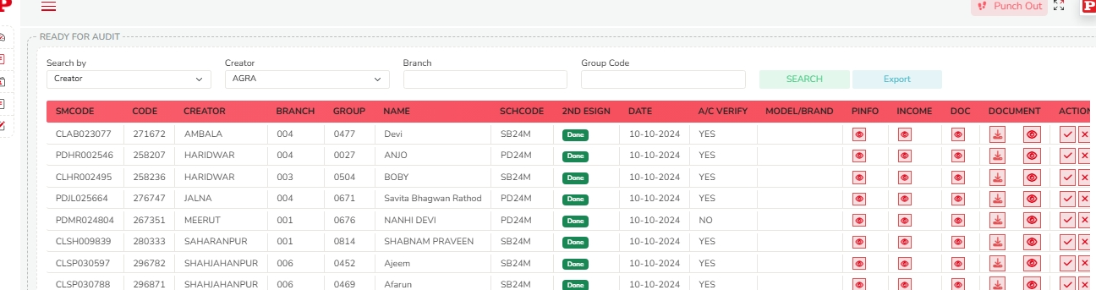

**NEFT DONE**

This platform provides comprehensive functionalities for managing NEFT transactions, including bulk approvals and handling rejected or returned cases.

1. **Bulk NEFT Approval**:
   * Users can upload bulk NEFT approval files. A sample file is available for download, which can be edited before re-uploading.
2. **NEFT Rejected/Returned Cases**:
   * Users can upload files related to rejected or returned NEFT cases. Similar to bulk approvals, a sample file can be downloaded, edited, and uploaded.
3. **NEFT Transaction Status**:
   * Users can check NEFT statuses based on date or creator.
     + **Date Search**: Requires selecting a 'from date' and 'to date'. Search results will display in a table format, including columns for code, creator, branch, city, SMCODE, SCH code, DT_Fin, name, bank name, PF, INC, amount, account, and IFSC.
     + **Creator Search**: Requires selection of the creator, branch, and group code.
4. **Action Options**:
   * The platform allows users to approve NEFT cases directly from the search results. Additionally, users can export the displayed data using the export feature.
5. **SBI Initiation**:
   * This function is specifically designed for the accounts department, enabling them to initiate NEFT cases directly within SBI from their end.

